Term 4 newsletter 2026 CLIL Visual Arts and Italian
Mrs Nadia Di Vincenzo and Dr Marie Petersen

Foundation
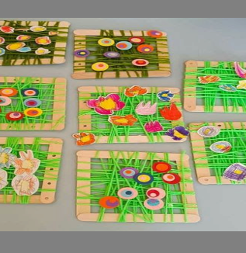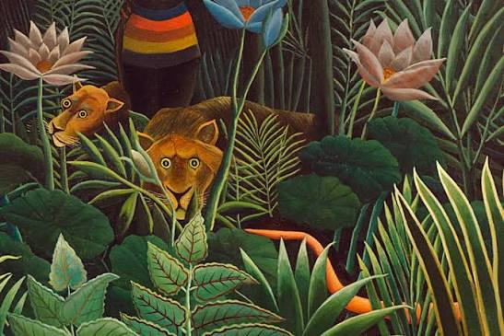
Our wonderful artists have a busy, tactile and vibrant term ahead as they develop their fine motor skills, experiment with colour and explore a variety of artistic techniques and textures.
Here is a sneak peek at what our Foundation students will be creating this term;
Henri Rousseau – Exploring the Jungle: Students will explore the work of artist Henri Rousseau, known for his imaginative jungle scenes. They will experiment with colour, shape and texture to create expressive jungle inspired artworks featuring animals surrounded by lush, decorative foliage.
Deep in the Jungle – Animal Silhouettes: Building on their jungle leaf print backgrounds, students will explore contrast, layering and the difference between foreground and background. They will create rich, multi toned jungle scenes using leaf printing techniques before adding a dramatic black animal silhouette of their choice, bringing their jungle artworks to life.
Paper Plate Weaving: To finish the term, students will explore textile art by transforming simple paper plates into looms. They will practise the over and-under weaving technique using colourful wool, developing their concentration, hand-eye coordination and fine motor skills while creating their own woven artworks.
You are warmly invited to visit the Italian/Visual Arts Room and admire our students’ artwork displayed in and around the room. We look forward to sharing their creativity and artistic achievements with you.

Grade 1 2
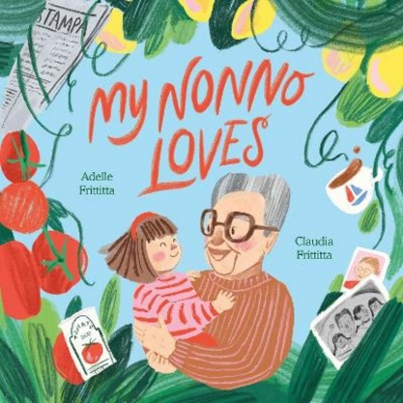
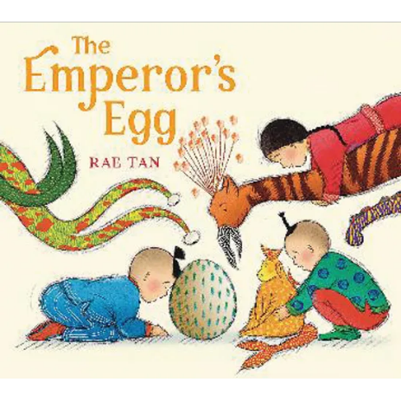
Students have been diving deep into storytelling and bringing beloved characters and settings to life through two wonderful texts.
Here is what our talented students are working on:
The Emperor’s Egg (By Martin Jenkins): After exploring the icy world of the Antarctic, students are channelling their inner creature designers! Taking inspiration from the text's themes of survival and unique adaptations, they are using their wild imaginations to invent and construct their very own 3D multimedia monsters. Inspired by My Nonno Loves…, students are celebrating family, memories and the beauty of nature as they step into the role of landscape designers, creating their own version of Nonno’s garden. They will construct a three-dimensional garden collage featuring paper flowers on a textured background. Using newspaper as a creative medium, students will also paint and transform recycled paper into a variety of colourful fruits, exploring texture, shape, colour and form while bringing their imaginative garden designs to life.
You are warmly invited to visit the Italian/Visual Arts Room and admire our students’ artwork displayed in and around the room. We look forward to sharing their creativity and artistic achievements with you.

Grade 3 and 4
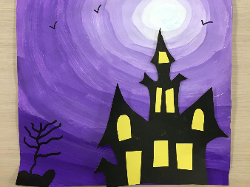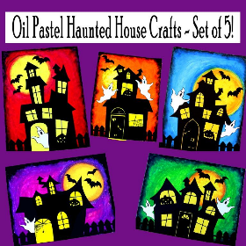
This term, students are continuing to develop their artistic skills by exploring texture, colour, contrast and composition through a range of engaging Visual Arts experiences.
Laurel Burch-Inspired Cats – Exploring Pointillism: Students are completing their colourful cat artworks inspired by artist Laurel Burch. Using the technique of pointillism, they are applying small dots of paint to build colour, pattern and texture, creating vibrant artworks full of personality.
Haunted Houses – Exploring Positive and Negative Space: Students will explore positive and negative space to create a dramatic haunted house artwork. They will experiment with colour theory, blending chalk and oil pastels to create a vibrant, glowing night sky. Using layering, smudging and gradient techniques, they will blend cool blues, deep purples and eerie oranges to capture the atmosphere of a spooky evening.
To complete their artworks, students will design and cut out black paper silhouettes of haunted houses, crooked trees, bats and ghosts. They will carefully arrange these shapes against their glowing backgrounds, exploring the contrast between light and dark while creating a sense of depth and atmosphere.
We look forward to another term of creativity, experimentation and artistic discovery as students continue to build their Visual Arts skills.
You are warmly invited to visit the Italian/Visual Arts Room and admire our students’ artwork displayed in and around the room. We look forward to sharing their creativity and artistic achievements with you.

Grade 5 and 6
Exploring Italian Heraldic Shields
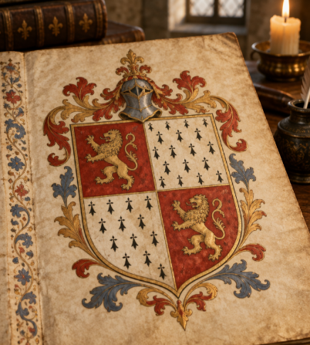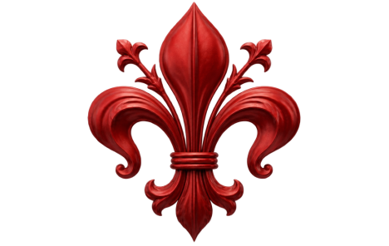

This term Grade 5 and 6 students will be exploring the fascinating world of Italian heraldic shields, discovering how symbols, colours and designs were used in medieval and Renaissance Italy to represent families, communities and important values.
Students will learn key Italian vocabulary related to shields, colours, shapes and traditional heraldic symbols. They will apply their knowledge of the Elements of Art to design and create their own unique shields, incorporating meaningful symbols and personal designs inspired by Italian heraldic traditions.
Throughout the project, students will develop their visual arts skills, cultural understanding and confidence in using Italian to describe their creative choices. This combination of language, history and art will encourage students to express their identity and creativity through their own individual designs.
We invite all families to become active participants in this learning experience. Your family stories, traditions and cultural connections are valuable sources of inspiration! Talk with your child about the symbols, colours and values that represent your family, share any stories about your cultural heritage, and explore whether your family has a crest, emblem or meaningful symbol. You might even enjoy designing a family shield together at home!
Try some Italian together:
- Lo scudo – The shield
- Il colore – The colour
- Il simbolo – The symbol
- La famiglia – The family
- Il rosso, il verde, il blu – Red, green, blue
Ask your child: “Quali simboli hai scelto e perché?” (Which symbols did you choose and why?)
We encourage families to take time to celebrate their child's creativity, ask questions about their design and invite them to share what they have learned in Italian. You are also warmly invited to visit the Italian/Visual Arts Room and admire our students’ artwork displayed in and around the room. We look forward to sharing their creativity and artistic achievements with you.

