SPECIALIST LEARNING OVERVIEW
2026 TERM 4: Performing Arts
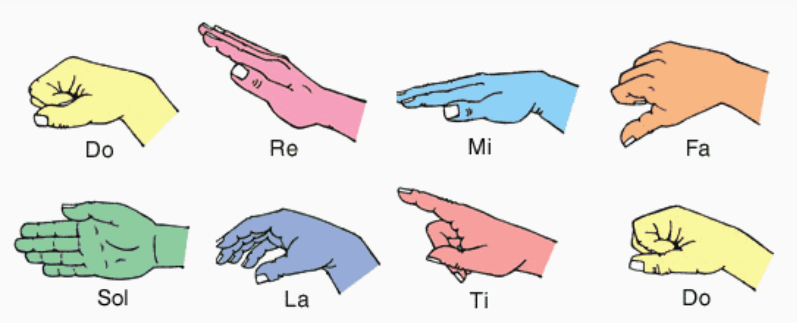
Prep
Students in Prep will be learning music through the Kodaly method of aural training. They will explore how to recognise high and low pitch through body representation and will be introduced to healthy singing technique. Prep students will also learn about feeling the beat and will complete activities and games to practise keeping a steady beat in their bodies.

Through visual icons and pictures, students in Prep will learn to identify how many sounds can be heard on each beat in preparation for reading and writing rhythms in later years. Songs and games will have a limited note range and will include opportunities for solo singing and improvisation. Some notable songs include Starlight, Bumblebee, Engine Engine and Reach Up High.

We will also be preparing an exciting Year Level song as in readiness to perform at an upcoming school event later in the term. More information about this will be communicated with families in due course.
Grade 1/2
Students in Years 1 and 2 will be learning music through the Kodaly method of aural training. Building on what they learnt last year, students will explore the Solfege notes so and mi and learn to recognise these notes in short musical patterns and represent them using the appropriate hand signs.

Year 1 and 2 students will also learn to recognise they rhythms taa and ti-ti through activities including circle chase games, call and response and solo singing opportunities. They will practise sight-reading these rhythms using body percussion and untuned percussion instruments and will experience compound metre through partner activities. Some notable songs include Lucy Lockett, Doggie Doggie and Bluebells/Wash The Dishes.

We will also be preparing an exciting Year Level song as in readiness to perform at an upcoming school event later in the term. More information about this will be communicated with families in due course.
Grade 3/4
Students in Years 3 and 4 will be extending their musical skills through the Kodaly method for aural training. Building on the notes already known, students will be learning to recognise and respond to the Solfege note high do through short songs and activities like Solfege Knock Out.

Rhythmic work will begin by revising known rhythms taa, ti-ti and saa before introducing and reinforcing tikkatikka through whole-class circle games, movement activities and an introduction to rhythmic dictation. We will begin singing in two-part rounds to build skills in harmony and ensemble work. Some notable songs include Apple Tree, Tideo and Charlie Chaplin.

We will also be preparing an exciting Year Level song as in readiness to perform at an upcoming school event later in the year. More information about this will be communicated with families in due course.
Grade 5/6
Students in Years 5 and 6 will be extending their musical skills in rhythm and melody through the Kodaly method for aural training. Building on prior knowledge, they will be learning to recognise notes from the Pentatonic Scale through singing limited range songs and completing melodic dictation.

In rhythmic work, students will further explore compound time and begin to sight-read short rhythms in a 6/8 time signature. Rhythmic dictation will be a key part of our learning, with students learning to write known rhythms upon hearing them and learning new rhythms ti-tikka and tikka-ti. Some notable songs include Boots of Shining Leather, Drunken Sailor and Down The River

We will also be preparing an exciting Year Level song as in readiness to perform at an upcoming school event later in the year. More information about this will be communicated with families in due course.
