SPECIALIST AREA NEWSLETTER
2026 TERM 4 OVERVIEW:
Prep
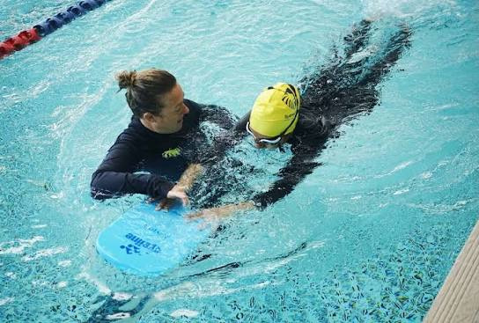
Physical Education – Foundation
This term, students will revisit a variety of fundamental motor skills and develop more complex movement skills through partner and small-group activities. These will include chest passing, catching, kicking, overarm and underarm throwing, forehand striking, two-handed striking, running and dodging.
There will also be an emphasis on developing fitness through a range of fun and engaging running activities and games. Participation, staying safe, demonstrating good sportsmanship and, most importantly, having fun will continue to be encouraged.
Perceptual Motor Program (PMP)
The Perceptual Motor Program (PMP) is a movement-based program designed to help younger students develop important fundamental skills, including hand-eye coordination, balance, fitness and visual tracking.
PMP will take place in the large hall on Wednesday afternoons from 2:30 pm – 3:30 pm

Swimming: Foundation (Prep) – Term 4, 2026
The Foundation Swimming Program for Term 4, 2026, has been scheduled for Monday 14th December to Thursday 17th December (Last week of Term 4).
This four-day intensive swimming program provides students with valuable opportunities to develop water confidence, improve their existing swimming abilities and build swimming skills and endurance.
Each day, students will participate in a 45-minute swimming lesson, conducted by an approved swimming instructor and organised according to their swimming ability.
Lessons will take place at Windy Hill Swimming Centre, with the following session times:
- Prep L: 12:00pm – 12:45pm
- Prep D: 12:45pm – 1:30pm
More information regarding the Prep swimming program is located on Compass.
Please ensure students bring a water bottle, wear their PE uniform and have runners for all Physical Education and sporting activities.

Grade 1 /2 – Levels 1 and 2
Physical Education:
This term, students will be developing and practising a variety of fundamental motor skills, as well as more complex skills through partner and small-group activities. These will include throwing, catching, ball bouncing, running, dodging, overarm throwing, two-handed striking, bowling, batting and modified game play.
There will also be an ongoing focus on fitness, with students participating in a variety of fun running activities, fitness challenges and games. Students will begin to explore the links between regular physical activity, health and wellbeing.
Participation, giving your best effort, staying safe and, most importantly, having fun are always encouraged.
Grade 1 /2 Swimming: This year, students in Grades 1/2 will participate in our school swimming program at Windy Hill Swimming Centre, commencing Monday 7th December and concluding Friday 11th December.
The program provides students with valuable opportunities to develop their swimming skills, water confidence and understanding of water safety. Swimming and Water Safety is an important component of the Victorian Curriculum, and we strongly encourage all students to participate in these lessons.
Further information regarding swimming times, transport arrangements and what students will need to bring are on Compass.
Reminders: Students are required to bring a water bottle, wear their P.E. uniform and have runners for all Physical Education lessons.

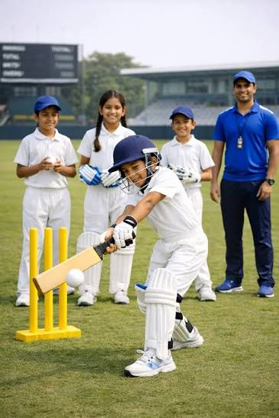
Grade 3/4
Physical Education – Levels 3 and 4
This term, students will develop their skills and understanding across a variety of sports, including Cricket, Tennis and Table Tennis. Students will focus on refining fundamental movement and sport-specific skills such as throwing, catching, running, dodging, forehand striking, backhand striking and two-handed striking.
There will be an emphasis on developing correct technique, understanding game rules and applying basic strategies to improve individual and team performance. Students will have opportunities to practise these skills through partner activities, small-group challenges and modified games.
Each lesson will also include a range of engaging fitness challenges and activities designed to improve students' mobility, coordination and overall fitness. Participation, effort, teamwork and sportsmanship will continue to be encouraged, with an emphasis on staying safe and having fun.
Grade 3/4 Swimming Program – Term 4, 2026
The Grade 3/4 Swimming Program will take place from Monday 16 November to Friday 20 November 2026. This five-day intensive program provides students with an excellent opportunity to build water confidence, develop their swimming skills and improve their swimming ability and endurance.
Students will participate in a 45-minute swimming lesson each day, conducted by an approved swimming instructor and organised according to their swimming ability. Lessons will take place at Windy Hill Swimming Centre.
Swimming Session Times
- Session 1: 12:00pm – 12:45pm – Grade 3P and some students from 4A
- Session 2: 12:45pm – 1:30pm – Grade 3M and some students from 4A
- Session 3: 1:30pm – 2:15pm – Grade 4F and some students from 4A
Participation, giving your best effort, staying safe and, most importantly, having fun are always encouraged. Students will also continue to explore the important links between regular physical activity, health and wellbeing.


Grade 5/6
Physical Education: Chris Harvey
This term, students will participate in a range of modified games, including Ultimate Frisbee, Cricket, Basketball and Table Tennis. They will develop and refine a variety of fundamental movement and sport-specific skills, including bowling, overarm and underarm throwing, ball bouncing, forehand and two-handed striking, running and jumping.
There will be an emphasis on understanding game rules, developing basic strategies and making decisions that enhance individual and team performance. Each lesson will also incorporate engaging fitness challenges designed to improve students' mobility, movement and overall fitness.
Students will be encouraged to demonstrate positive participation, teamwork and sportsmanship while always prioritising safety and having fun. They will also begin to explore the important connections between regular physical activity, health and wellbeing.
Grade 5/6 Friday Sport
During Friday Sport, students will have the opportunity to participate in a variety of team sports and modified games. Activities may include Cricket, Bat Tennis, Volleyball, Futsal (Soccer) and Basketball.
Our Grade 5 students will participate in their Basketball Gala Day on Friday 30th October, while our Grade 6 students will have their Gala Day on Friday 23rd October. Both events will be held at the Coburg Basketball Stadium.
The Friday Sport program aims to provide students with opportunities to participate in well-organised, enjoyable and challenging sporting experiences that extend upon the skills and knowledge developed during Physical Education lessons.
Importantly, students will be encouraged to put our school values into practice in a sporting environment by demonstrating respect, teamwork, responsibility, resilience and positive sportsmanship.

