Grade 4 Newsletter - Term 1, 2022

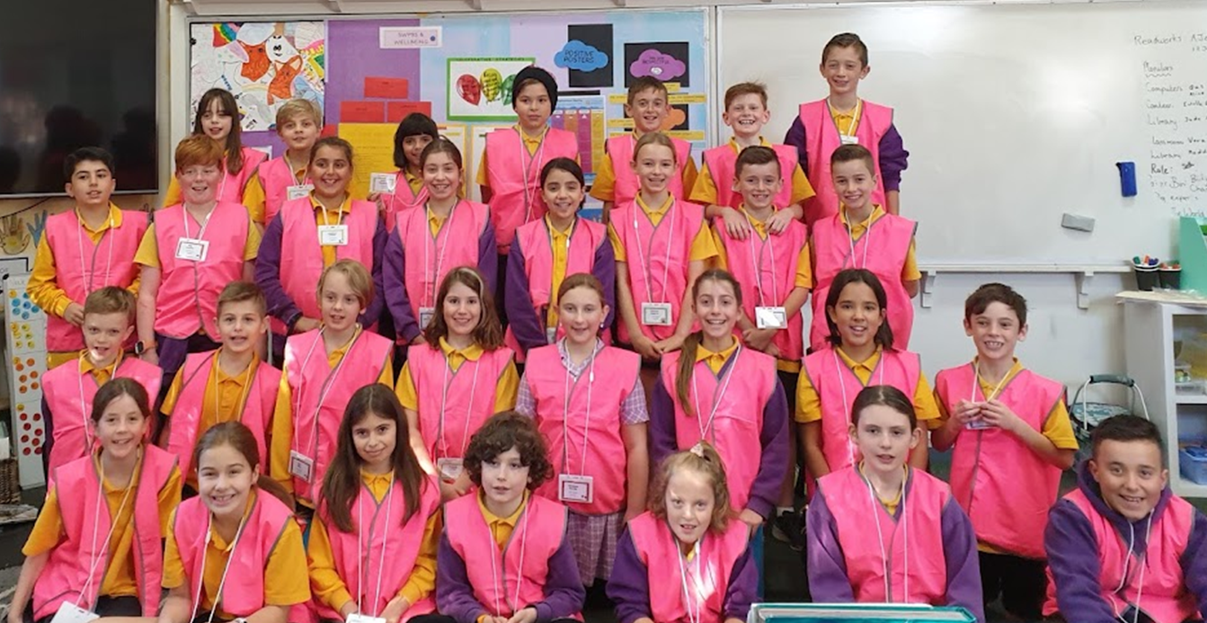
Issue #1 March 2nd 2022

Dear students, parents and caregivers,

Welcome to a very exciting year as we at Coburg West Primary School (CWPS) make the transition to straight grades! This will enable us to focus more specifically on year-level curriculum in smaller teaching teams. The Year Four team will no longer need to be so concerned with NAPLAN and settling students into a new building, allowing us to apply a stronger focus to leading 3/4 Sport and take on our new exciting role at Prep buddies. We are proud of the way the students have already made an awesome start to this added responsibility, eating lunch with the Prep classes before showing them around the yard and how to uphold all our school values.
Our team consists of three amazing teachers who have already taken on the planning, organisational and administrative extras that come with a smaller team:
Jo Rigby (4R, Room 15) | Rhiannon Mardesic (4M, Room 16) | Isaac Krauss (4K, Room 17)
While maintaining a connection with her role in developing the School Wide Positive Behaviour Framework, Jo will further take on the role of leading the team in Writing this year. | Leading the team in the areas of SWI and Reading while holding the role of PLC Leader across Grade 3 and 4. | Leading the team in the area of Mathematics, whilst also taking on the added role of Team Leader for 2022.

Throughout the year, we will ensure that the past two years of Remote Learning is considered when planning and teaching. We will support the social, mental and emotional needs of our students alongside the academic needs that may have arisen throughout the last two years. It should be an exciting year and we encourage you as the wider community to get involved whether it be organising a meeting with your child’s teacher, or discussing the learning being undertaken with your child.
Welcome once again,
Jo, Rhiannon and Isaac

Important dates
Meet the Teacher | Tuesday 8th March
Excursion to Werribee Zoo | Wednesday 9th March
Labour Day | Monday 14th March
End of Term | Friday the 8th April

MATHEMATICS
Place Value
Place Value is a vital concept for students to understand. This is one of the Big Ideas in Mathematics that underpins future mathematical understandings. During term one we will spend time developing place value understandings. All students will be extended from their current knowledge and ultimately use a wider range of numbers. Students will start at three-digit numbers, extending to millions, if able. If ready, some students will be introduced to decimal tenths and hundredths.

Place value is the basis of our entire number system. A place value system is one in which the position of a digit in a number determines its value. In our number system, called base ten, each place represents ten times the value of the place to its right. You can think of this as making groups of ten of the smaller unit and combining them to make a new unit – for example, ten ones make one ten. At school we refer to this as renaming. Parents might recall this as trading or regrouping.

The value of a digit depends on its place in a number. This is its place value. Looking at the number 369, you can see that there is a three in the hundreds place which means 100, three times = 300, six in the tens place which means 10, six times = 60 and nine in the ones place, which means one, nine times = 9.
369 = 300 + 60 + 9. Total = 369.

This number could be written in three forms – numeral form, expanded form, or word form.
Example: 369 = numeral form
300 + 60 + 9 = expanded form
Three hundred and sixty-nine = word form

Students increase their understanding and use of larger numbers by making, naming and recording numbers, ordering and comparing numbers, counting in place value parts, (such as ones, tens, hundreds both forward and backwards from a variety of start points), renaming numbers in more than one way (for example 123 can be renamed various ways such as 1 hundred, 2 tens and 3 ones or 12 tens and 3 ones or 1 hundred and 23 ones or 11 tens and 13 ones etc.), and rounding to each place of the number they are working on. This helps students to see numbers flexibly and fluently.

Mental Computation
At the end of the term, staff will develop students’ mental computation with addition. They will add using the efficient addition strategies. Staff are aiming to extend students to move from count all (where the child counts all the counters), and count on (where the child starts at the bigger number and counts on the rest). Efficient strategies include, doubling, near doubles (where the child uses a double and then adds one more, such as four plus five), tens facts and bridge to ten (where the child makes a ten first and adds on the rest, such as eight plus five is equal to eight plus two makes ten, plus three makes 13). Students will then move to modelling, recording and renaming the formal addition algorithm, making links to real world problems. Finally, students will make links between simple addition and subtraction to 20. They will begin to explore fact families if ready, for example 7+5=12, 5+7=12, 12-5=7 and 12-7=5.

Measurement
Grade 4 students will also be investigating time, calendars, timetables, chance and data graphing, and the best units of measure to use when measuring a particular object, such as centimetres, to find the length of a shoe.

ENGLISH
Reading and Viewing
At the beginning of the year the focus is on identifying and revising reading strategies that students can use before, during and after reading. We also focus on reading comprehension, especially with finding the main idea, visualising when reading, making connections, interpreting explicit information and making inferences. Each reading lesson includes the following – a whole class focus, independent reading time, teacher focus groups, individual reading conferences and an opportunity for all to share and reflect.

During Independent Reading, a number of books are available for students to select from the classroom libraries. Students have a scheduled reading conference and will set reading goals to work towards achieving. As the term continues, they will be introduced to Reader’s Notebooks. More information will be shared about these during the term.

Writing
This term there will be a teaching focus on imaginative writing, in particular, descriptive and narrative writing. Before the end of term, students will be introduced to persuasive writing. Activities include revising text structure, constructing sentences, selecting interesting words and using figurative language effectively to write succinct, engaging pieces. We will also explore grammar, looking particularly at synonyms, adjectives, nouns, verbs and adverbs, as well as paragraphing. Spelling strategies will also be explored and taught. Through shared, guided and independent writing, students will learn to understand the writing process and each element of it. That is, Planning, Composing, Recording, Revising, Editing, Publishing and Conferencing. Students will create pieces of work in written and electronic form with the purpose of sharing their work.

Speaking and Listening
Speaking and listening skills are necessary for effective communication. At the beginning of the year students are getting to know each other. Formal and informal speaking and listening opportunities such as class discussions, circle time and presentations are being incorporated into daily learning activities. Students are learning about speaking clearly and audibly, asking and answering relevant questions and communicating ideas effectively. We are also focusing on the importance of listening carefully to instructions and how to be a ‘good listener’.
INQUIRY TOPIC
Compare and contrast: The geography of South America, Africa and Australia

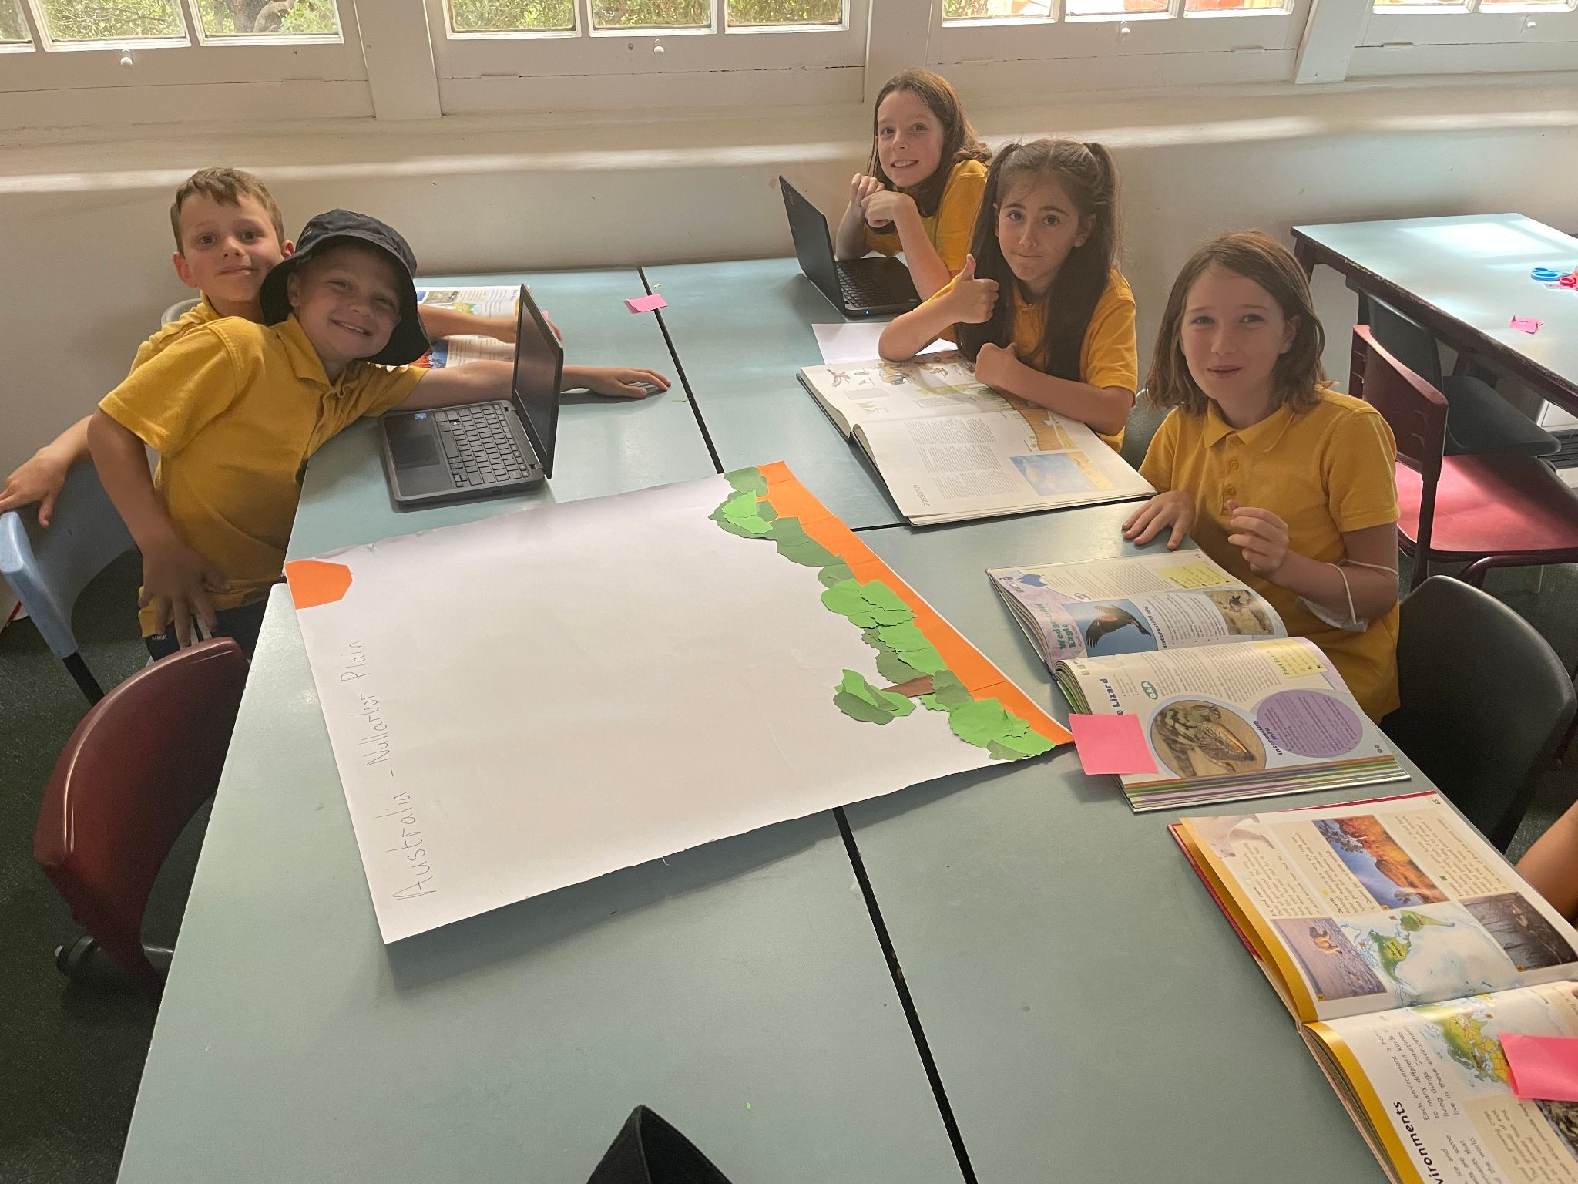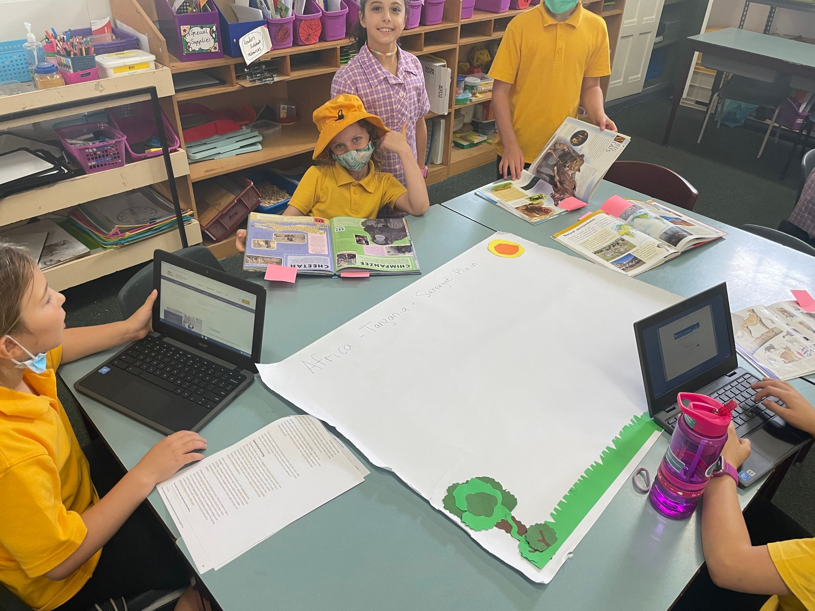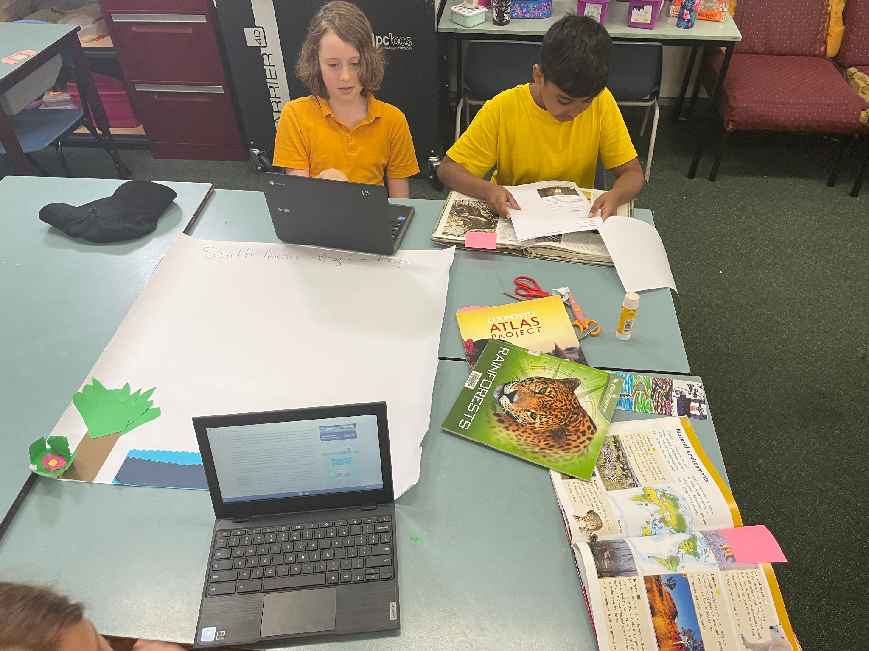

Inquiry this term will take on a strong Geography focus. Starting on a broad scale students will look at different maps and what information they convey. These will include topography, temperature and rainfall maps. To connect to their own life, students will collect these geographical measurements themselves using thermometers, rain gauges and a wind measurement tool.

Building on their understanding of geographical measurements the unit will explore factors that affect climate, and also what climate affects in different countries like the growth of crops and the presence of wildlife.

Student learning will be supported through an excursion to Werribee Zoo and through the use of rotations, where students will then explore the geographical concept of place including interconnections, natural environment, and people and culture.

The unit will culminate in a project giving students the chance to display what they have learnt.

VALUES

Our Values planning for 2022 centres around The Resilience, Rights and Respectful Relationships program.

During Term 1, classes in Grade 4 explore the concept of Emotional Literacy. They will learn to name and recognise specific emotions, both positive and negative that may be experienced at school.

Students will discuss events and activities that may trigger these emotions, in the classroom and playground.

Through exploration, discussion, role play and activities, students will be encouraged to contribute ideas which could provide positive support towards their peers when dealing with a specific emotion or emotions.

In addition, students will define their personal strengths and practise team building strategies through cooperative games, learning how to adapt these strengths to everyday situations. This will be supported by students creating individual goals to develop emotional strength to learn and thrive at school.

Specific teaching of our school values will continue, with teachers taking opportunities, on a daily basis, to articulate and model the positive actions contained within our school matrix. Through this, students will continue to develop and practise their knowledge and understanding of our school values, our rights and our responsibilities.

COBURG WEST SCHOOL VALUES
WE ARE LEARNERS, WE ARE SAFE,
WE ARE RESPECTFUL, WE CARE ABOUT EACH OTHER

INFORMATION and HOME LEARNING

To keep up to date with the Grade 4 Unit please go into www.cobw.vic.edu.au and click on learning teams, then select Year 3/4. This is our blog. We will post important information, area newsletters and home learning tasks throughout the year.

Formal weekly home learning tasks will begin towards the end of Term One, 2022. Details about home learning and expectations will go on the 3/4 Blog in due course.

TERM DATES 2022

Term One: 28th Jan – 8st April
Term Two: 26th April – 24th June
Term Three: 11th July – 16th September
Term Four: 3th October – 20th December

Thank you for reading this. From the Grade 4 Team.

