Dear students, parents and carers,
Welcome to Term 4; a very busy and exciting term.
For Grade 5s it is a time to prepare for leading the school next year in 2020.
For Grade 6s it is the end of your primary school journey as you prepare to transition to high school.
We look forward to the Spring Vibes school fete and the performances of the first Coburg West school musical; Mary Poppins!
We begin preparing for Grade 6 Graduation Night, which will be held on Wednesday 18th December at 7.00pm.
Two activities will take place before the ceremony:
- Family gathering in the courtyard from 6.00pm
- Grade 6 students and teacher’s dinner in the small hall from 6.00pm

Whilst the grade 6 students are enjoying their meal, their families are invited to gather in the courtyard to reminisce, share stories and to farewell, each other. Light refreshments and finger food will be served to parents and carers.
We have some helpers but still need more.
If you can help with any of the following, please contact Ms Meagher directly, highlighting the areas on the form attached below.
*Purchasing of food for the parent gathering
*Courtyard set-up from 4pm for the parent gathering
*Setting up the small hall from 9am for the grade 6 dinner
*Preparation of food during the day for the gathering
*If you are helping and your child would like to help, they are most welcome to help serve on the night.
*Clean up and pack up of the small hall at 6.45pm
*It is the school tradition that the grade 5 parents and students assist in sending off the grade 6 students.
More information will follow about graduation in the coming weeks. We will be working on choreographing a Boys, Girls and Combined dance, beginning practice in Week 4.
Looking forward to a fun packed term with your wonderful children.

Kind regards,
Ms Simone Meagher and the 5/6 Teachers: Ms Blatti, Ms Green, Mr Niciak, Ms Osman, Ms Quigley, Ms Rigby, Mr Rye

The following is an overview of what we will be learning in class this term.
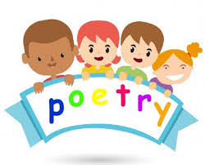
English
In reading, students continue to investigate how text structures assist understanding of text types. Through the classroom library, they will explore how language features, images and vocabulary influence interpretations of characters, settings and events. In literacy circles, they will be given roles such as, discussion director, word wizard, literary luminary, cunning connector, character captain and artistic adventurer to analyse and explain literal and implied information from a variety of texts. They will describe how events, characters and settings in texts are depicted and explain their own responses to them. A large focus for the term will be on reading poetry.
In writing, our focus will be on narratives and poetry. Students will be exposed to a variety of narratives and poems. Students will examine different poetic structures such as, haikus, limericks, ballads, cinquains, diamantes and acrostic poems. They will explore the stylistic features that make these poems both similar and unique. They will then plan, draft and publish their own poems using digital resources. Students will continue to learn their weekly spelling words and complete set grammar tasks.
In speaking and listening, students will contribute to group discussions, they will clarify their ideas, develop, share and evaluate information. When presenting their own ideas, they will practise varying their language according to group size, needs and expertise of the audience. Students will be required to present information found in their inquiry unit and perform poetry.

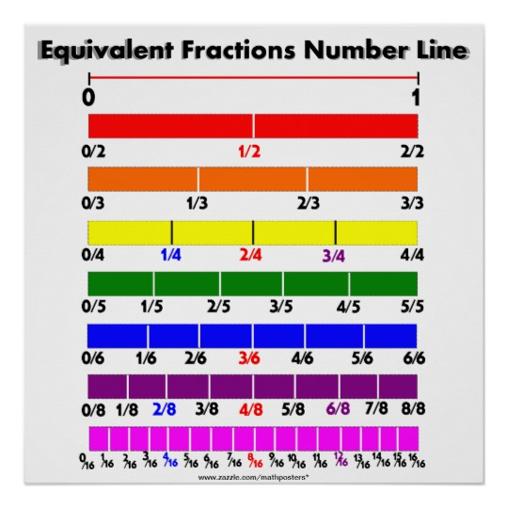
Mathematics
In Term 4, students will continue their study of whole numbers, fractions, decimals and percentages. Students will demonstrate their understanding by converting between them and placing them on number lines. Looking at patterns and algebra, students will create and solve number sentences, exploring the use of brackets and adhering to the correct order of operations (BIDMAS). Students will also investigate everyday situations that use integers. Problem solving will continue to be a focus and students will be required to choose and explain the mathematical strategies they use. They will need to justify their reasoning and use estimation to check the reasonableness of their answers.
In applied, students are identifying, measuring and creating angles on a straight line, angles at a point and vertically opposite angles. We will be investigating combinations of transformations on simple and composite shapes, including creating tessellations. Students will explore the Cartesian coordinate system using all four quadrants.
It is advised that Grade 6 students leave primary school with multiplication fluency, being able to mentally recall their times tables facts, up to their 12’s.

*All students in Grade 5/6 have their own log in to Manga High and can access tasks at home to practise skills and work towards gaining points in tasks. They are encouraged to work on their areas of need throughout the week, as part of their regular home learning.

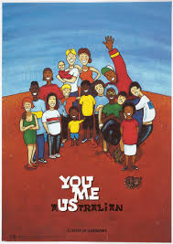
Inquiry
This term our focus for Inquiry will be the history of Australian immigration, titled: Where do we come from? The students will research and investigate their own family history, in particular their immigration stories.
Students are presented with the inquiry question “Who were the people who came to Australia?” and “Why did they come?” The inquiry question lays the basis for learning. To ensure learning is relevant, students begin by considering the diversity around them.
By the end of the unit, students will understand that migration throughout Australia’s history contributes to the diversity within their class, school, and community. Australia has undertaken many migration schemes for many different reasons. The learning will encompass three migration schemes: migration during Australia’s Gold Rush, Post-war migration and refugee migration.
To culminate the unit of work, students will compile a suitcase containing aspects of their family’s immigration story. The suitcase can include artefacts, passports, written immigration accounts, photos etc.
Gr 5/6 will have an open afternoon towards the end of term to showcase our immigration stories in the form of a suitcase.
Values
Term 4 provides a great opportunity for students to explore the concept of resilience. The end of the year sees our Grade 6 students transitioning to High School and our Grade 5’s becoming the leaders of the school. Through our values program this term, we hope to help students find a strong sense of purpose and self- belief through discussion around supportive social networks, embracing change and being optimistic. Our program looks at developing self- nurturing as well as problem solving strategies to help cope with new expectations and goals. Through strategies such as values lessons, circle time and transition sessions, we hope to help students enter 2020 with a positive, self-confident attitude

