SPECIALIST AREA -GREEK
2026 TERM 4 OVERVIEW
Teacher: Ms Betty Koklanis




Grade 1 & 2


This term, our Grade 1 and 2 Greek class will explore the vibrant world of Greek music, songs and dance! Through fun, interactive and movement-based activities, students will discover how music and dance bring families and communities together, celebrate special occasions and keep Greek traditions alive across generations.
Students will learn about traditional Greek dances and the regions they originate from, discovering how dance styles, music and traditional costumes reflect the rich diversity of Greek culture. They will experience the joy of dancing together, learn about customs associated with Greek celebrations, develop their listening skills by recognising traditional musical instruments and exploring rhythm, and identify familiar Greek words and phrases in songs.
Grade 3 & 4



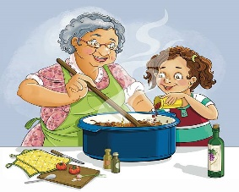
This term, our Grade 3 and 4 Greek students will explore Greek food and cuisine! Through fun, interactive and hands-on activities, students will expand their Greek vocabulary related to food and drinks, learn about traditional Greek dishes, and discover the important role food plays in Greek culture and family life.
Students will practise useful Greek expressions for everyday dining situations, including passing and requesting food, expressing likes and dislikes, ordering at a restaurant, and using common expressions. Students will also explore Greek dining etiquette and table manners through language games, restaurant role-plays, quizzes, short video clips and creative activities.
Students will have the opportunity to complete a Greek Food Project, where they will research and present a Greek dish to the class, sharing its ingredients, how it is prepared, and any cultural or family traditions associated with it.
Grade 5/6

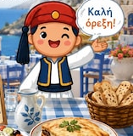

Building on students’ enthusiasm for Greek cuisine, we will continue with our theme of Greek food by delving deeper and exploring traditional dishes, desserts, family recipes and the customs that bring people together around the table. Students will further develop their Greek vocabulary and strengthen their reading, writing, speaking and listening skills through interactive quizzes, recipe activities, menu exploration and restaurant role-plays. They will learn to describe ingredients, flavours and textures, follow simple recipes in Greek, express preferences, and practise useful expressions for ordering food and interacting politely in different dining situations.
A highlight of the term will be a Greek Food and Recipe Project, in which students will research a traditional Greek dish or dessert, or a share recipe from their own family. They will present their chosen recipe to the class in Greek, describing its ingredients, preparation, and any cultural or family traditions connected to it. Students’ work will then be compiled into a class Greek Recipe Booklet, celebrating the rich diversity of Greek cuisine.
Through these activities, students will deepen their understanding of Greek culture while developing confidence in using Greek in meaningful, real-life contexts.

