Grade 5/6 Home Learning Week 6 Term 1
This week’s focus is on MATHEMATICS!
This term we have been focusing on place value and 3d shapes.

TASK 1: Look at the list below of volcanoes in Asia. Your task is to order the 10 tallest volcanoes from largest to smallest in the table below and then fill in the relevant information in the other columns. You can draw and complete the table in your home learning book.

Name of volcano | Elevation (height in m) | Write in expanded form (1000 + 500 + 40 + 3) | Round to the nearest thousand | Round to the nearest hundred
1
2
3
4
5
6
7
8
9
10

- Sabalan – 4,811m
- Taftan – 3,941m
- Mount Agung – 3,031m
- Mayon – 2,463m
- Mount Damavand – 5,610m
- Mount Kazbek – 5,033m
- Mount Rinjani – 3,726m
- Mount Fuji – 3,776m
- Mount Kilimanjaro – 5,895m
- Mount Sumbling – 3,371m
- Huaynaputina – 4,850m
- Mount Lawu – 3,265m
- Mount Merbabu – 3,145m

TASK 2: On the next page you are to work out the relevant information for the 3d shapes. Edge- where two faces meet Vertices a point where two 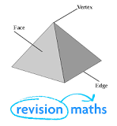or more edges meet.
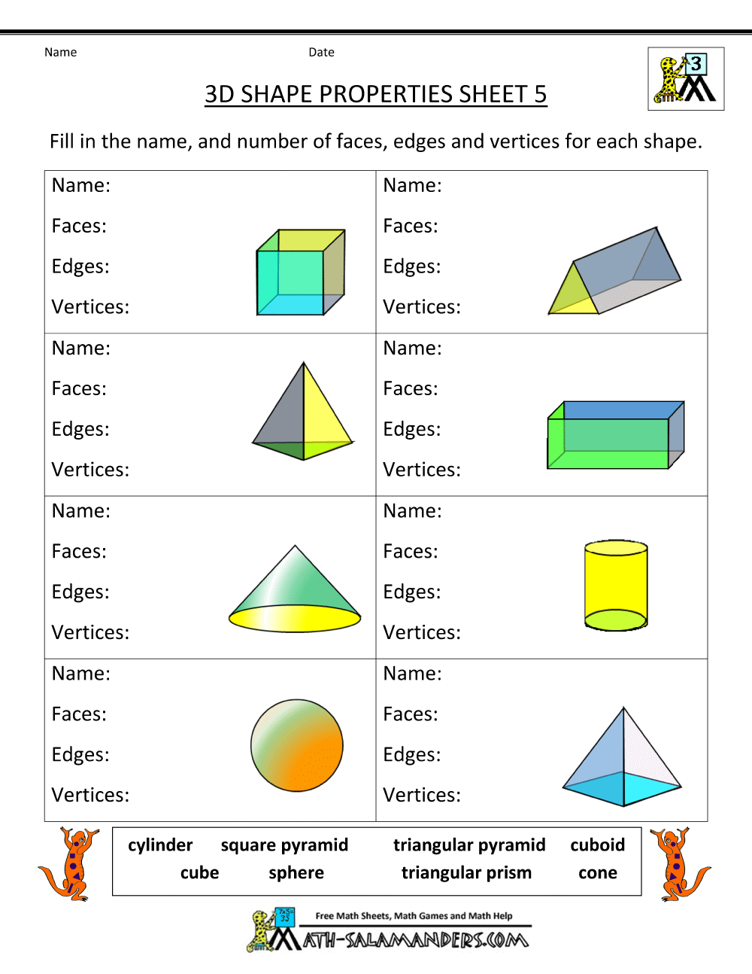

Week 6 Spelling words

decimal | fractions | measurement | statistics | numerator
multiplication | equations | percentage | operations | denominator

