WEEK 1 TERM 1 2019 HOME LEARNING
Hi wonderful students! Welcome to the first home learning for 2019.
I hope you enjoy the challenge which allows you to share some special moments in your life so far!
CHALLENGE:
Each student will receive a paper bag and a description of the challenge.
You need to decorate your paper bag with colours, drawings, cut outs, photos- whatever you would like to represent you!
Inside you need to place 4 items, no more, no less that are special to you.
They must fit in the bag and you need to think about the significance of each piece. If they will not fit in the bag, you will need to be creative when thinking about how they can be included e.g. a photo or drawn picture, or a note or letter.
We are looking forward to hearing your stories. Have fun!
Spelling words:
individual | personal | unique | memories | create | significant
decorative | special | personality | growing | change | present

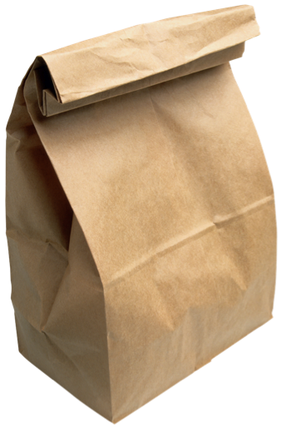
Jo

