5/6 Homework Term 1 Week 3

CHINESE New Year

*Read the story of the Chinese Zodiac on the next page.
*Rewrite the entire story in your own words with a different ending. Remember to include detailed character descriptions. Consider what positions the other animals placed. This should be at least one page long.
*Find some examples of Chinese writing and copy them using pencils or pens into your homework book. 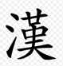
*Use google translate to try and write your name using Chinese Characters.
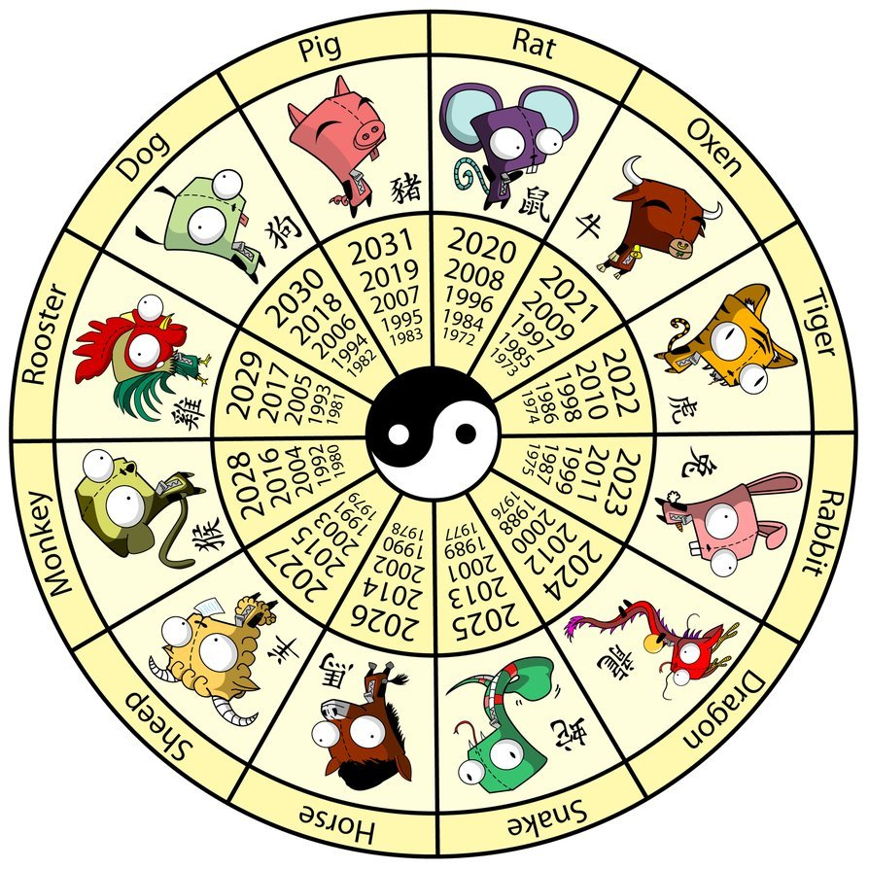
*Can you learn to say your name in Chinese Traditional ?

Spelling Week 3
This term we are going to be studying “Our Asian Neighbours”. Here is a list of Asian countries to learn for your spelling words next week.
*Please use a map to locate where each of these countries are, to be ready for some geography work in class this week.
Sri Lanka | Myanmar | Indonesia | China | Thailand | Nepal
Cambodia | Vietnam | Philippines | Malaysia | Laos | Papua New Guinea

