Grade 5/6 Home Learning Week 6 Term 4
This week’s focus is on MATHEMATICS!
At the moment, we are looking at the Cartesian plane and plotting coordinates.

TASK 1: Look at the treasure map below and write the coordinates for each object (shown with a dot) on the sheet below.

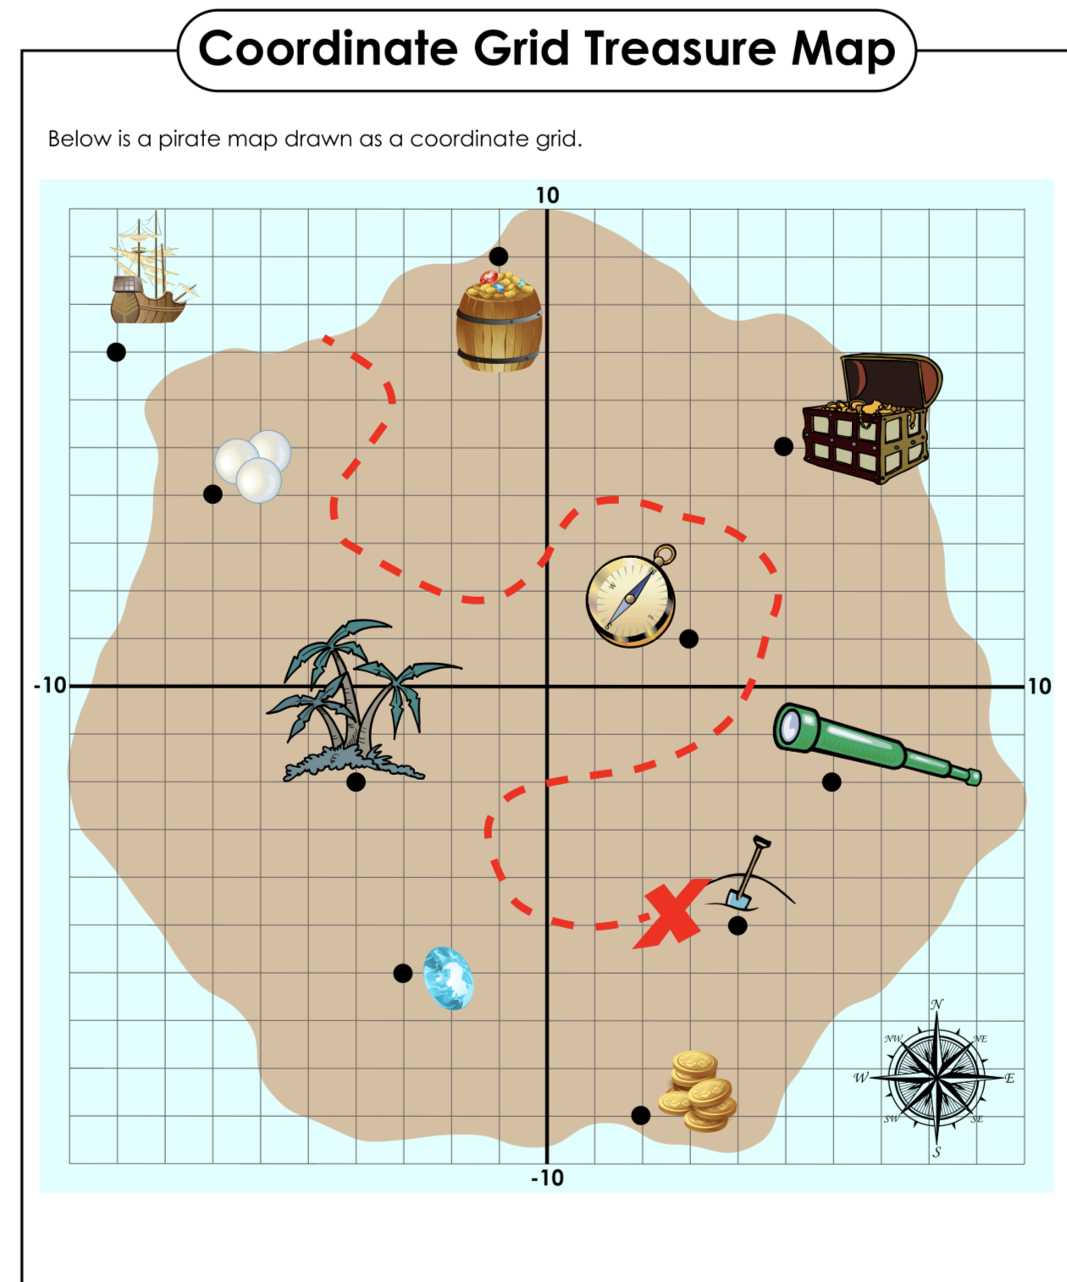
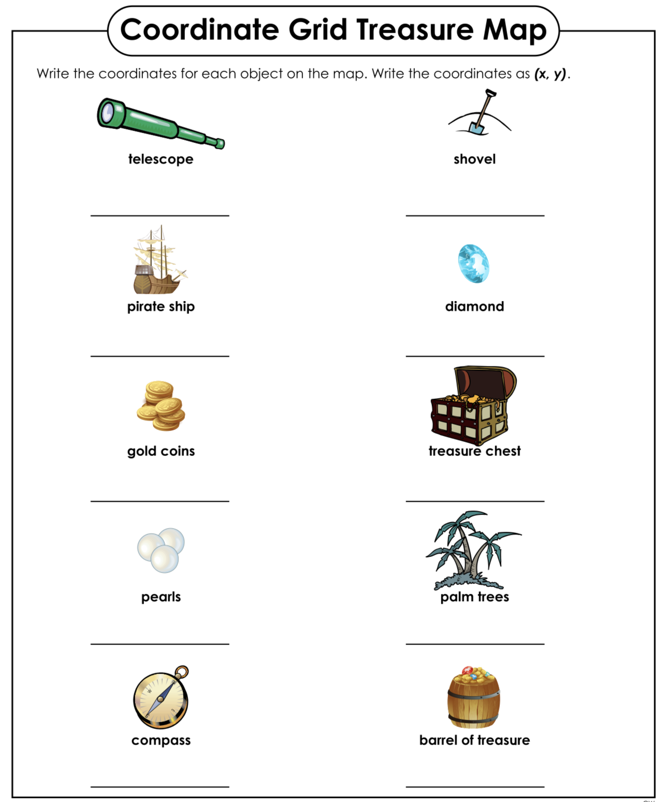

TASK 2: Create your own mystery image.
Use your creative skills to come up with your own mystery 2D drawing!
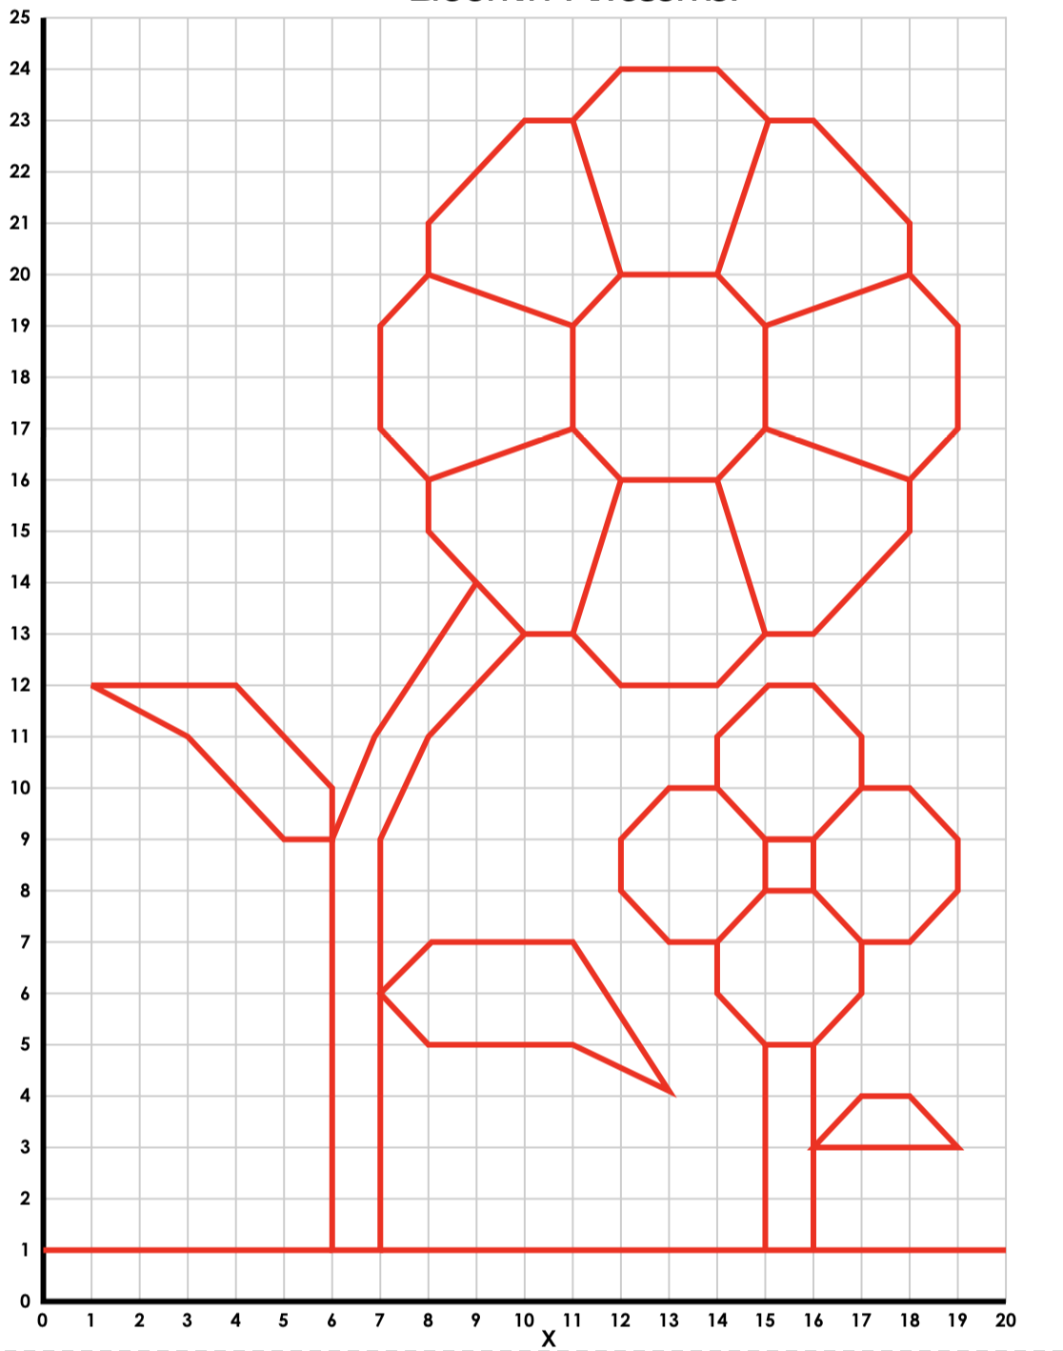
Here is an example.
Note how the lines are drawn using a ruler so they are straight and not curved.
Note that each line begins and ends at the corner of a square within the grid.

-You must draw your image on the grid provided (choose GRID 1 for only positive numbers, or GRID 2 for positive and negative numbers.
- You must give the ordered pair of coordinates for each part of the drawing, using the correct format as explained below:
- You must label your grid with the x and y axis as explained below.
- Ask someone to have a go at unlocking your mystery image by working through the coordinates that you have supplied. You will need to print off a blank GRID 1or GRID 2 for this.

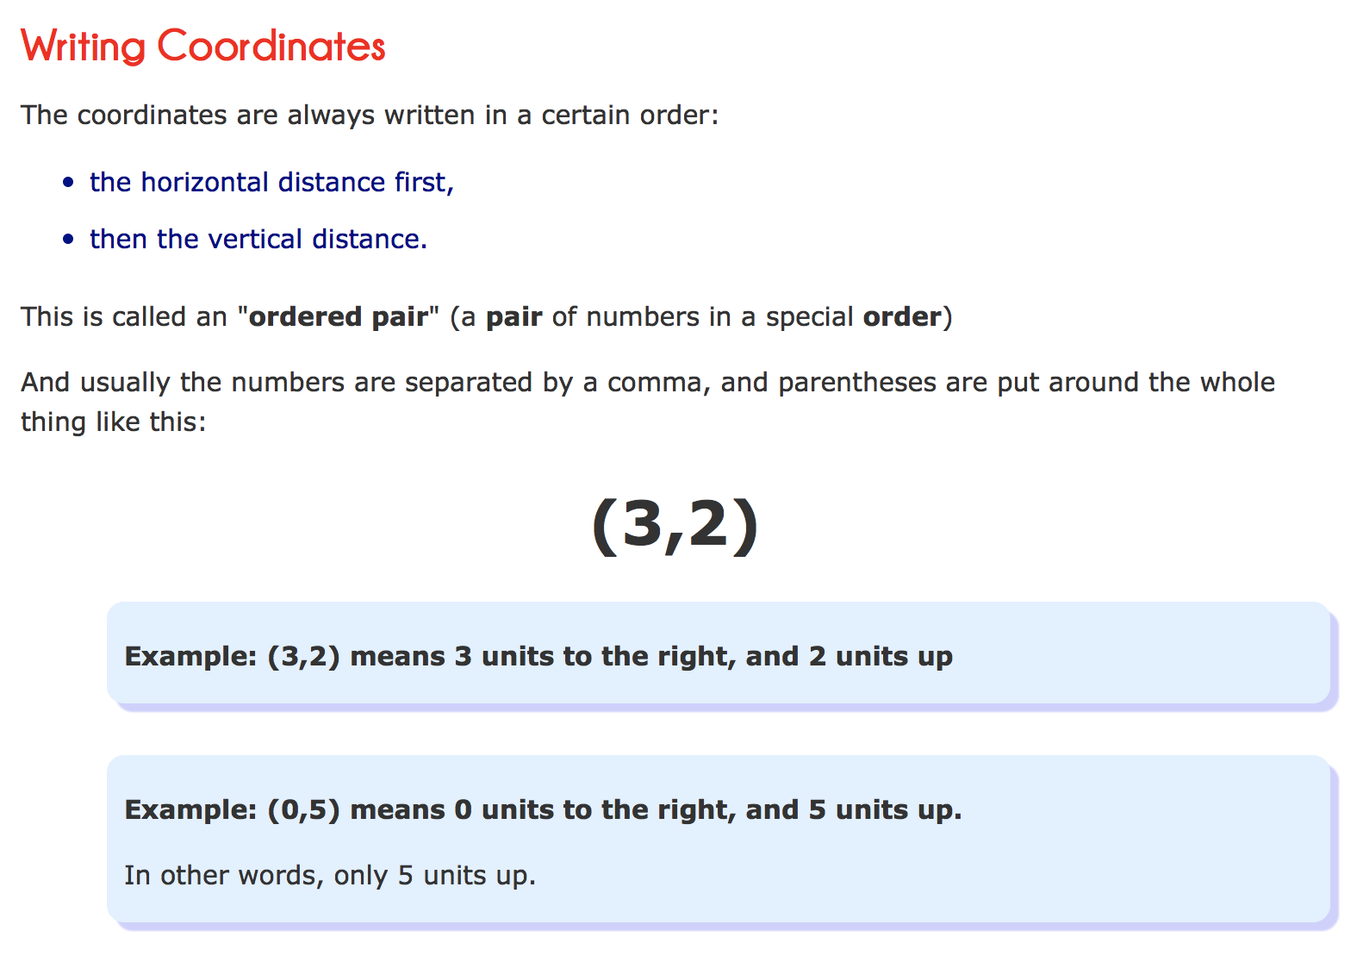

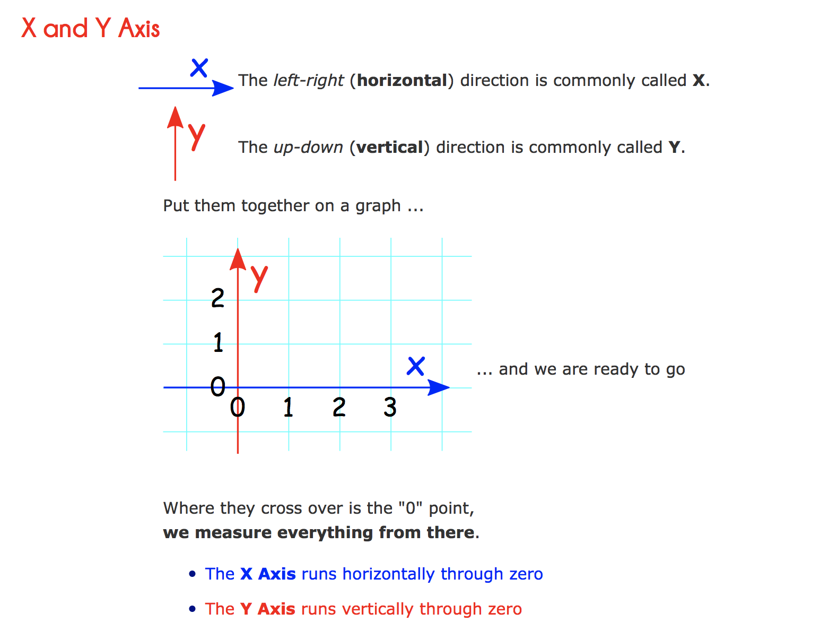
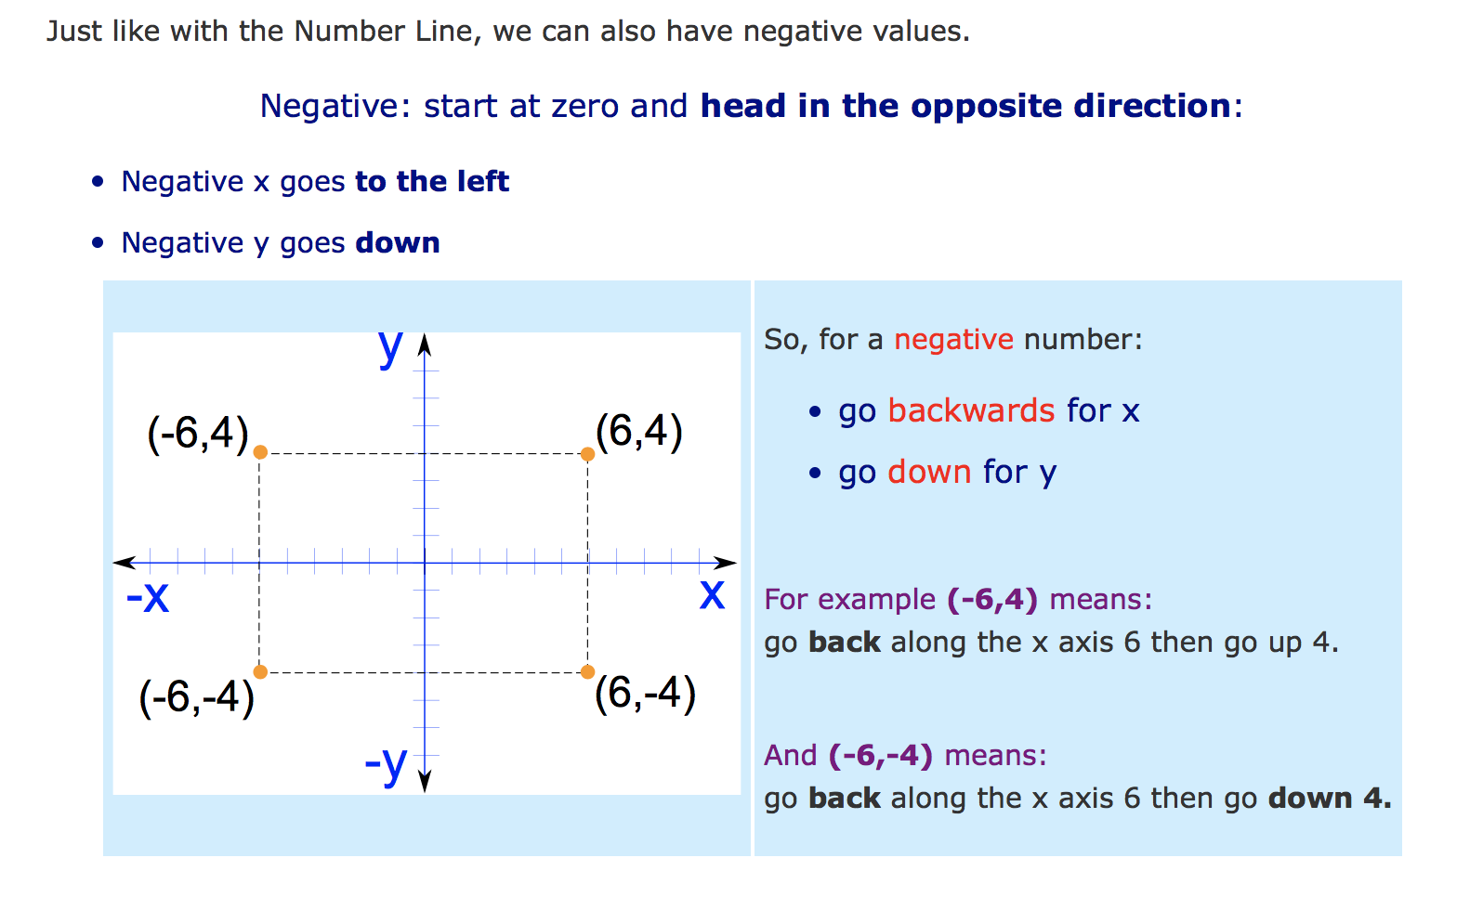

GRID 1.

OR GRID 2.

MANGA HIGH:
1. Go into the games section and play Transtar Reflections.
2. Assigned: Special Number Sequences.

SPELLING
horizontal | vertical | opposite | Cartesian | plane | axis
coordinates | quadrant | positive | negative | ordered | plotting

