Grade 5/6 Home Learning Term 1 Week 7
This week our focus is on VALUES. Our Coburg West value in Term 1 is CO-OPERATION.

Complete TASK A, AND TASK B, C or D.

TASK A: Analysing Images
Look at the following BLOBS images:
1.BLOB tree
2.BLOBS in the playground
3.BLOB bullying
4.BLOB classroom
5.BLOB football
On the images, label each character with C for co-operating or NC for not co-operating.
Then create a table of CO-OPERATING or NOT CO-OPERATING actions and behaviours that you can see in the pictures, for each of the images, (or fill in the ones below).
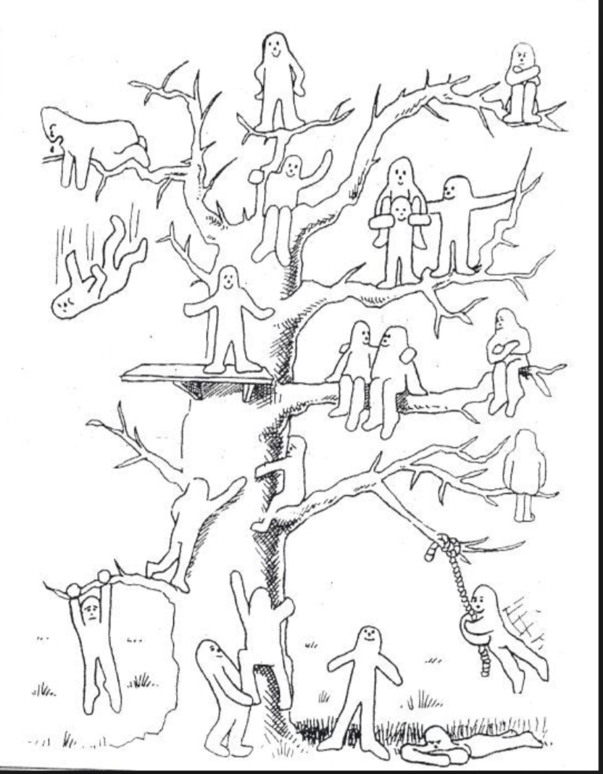

- BLOB Tree
CO-OPERATING | NOT CO-OPERATING

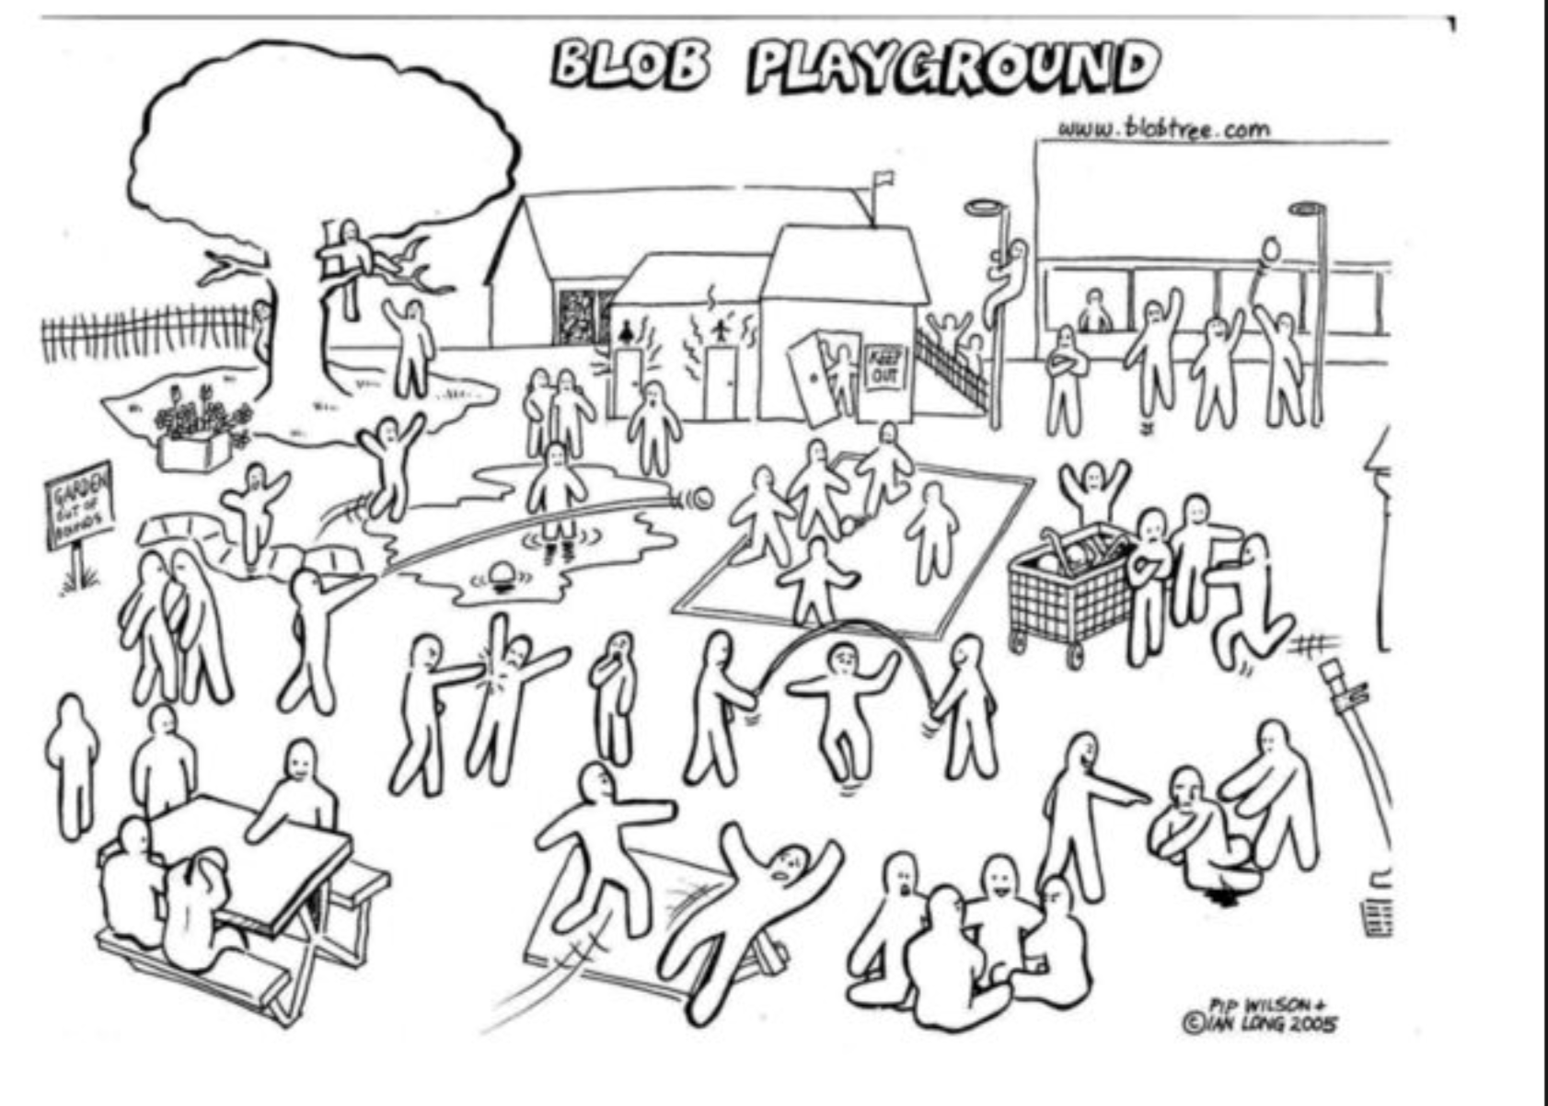
- BLOBS in the playground
CO-OPERATING | NOT CO-OPERATING

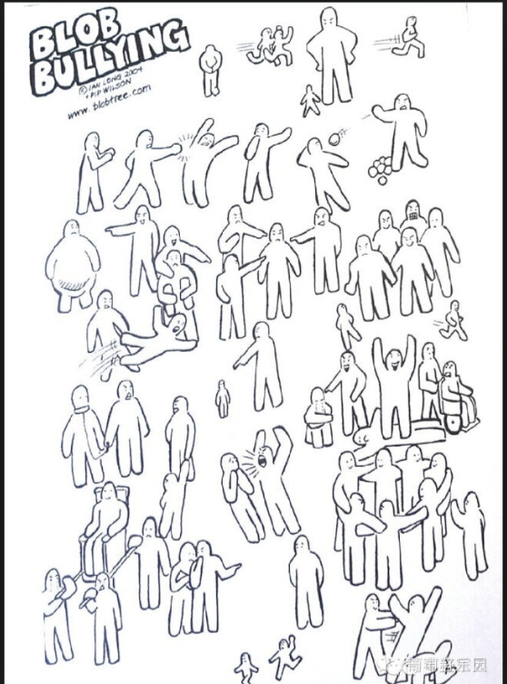

BLOB bullying
CO-OPERATING | NOT CO-OPERATING

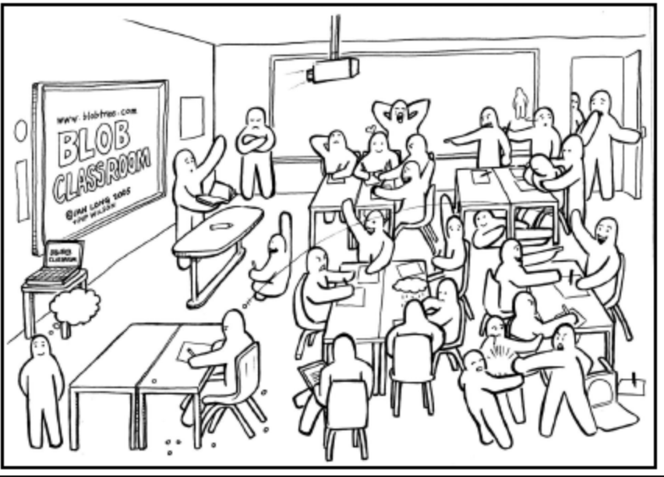
BLOB classroom
CO-OPERATING | NOT CO-OPERATING

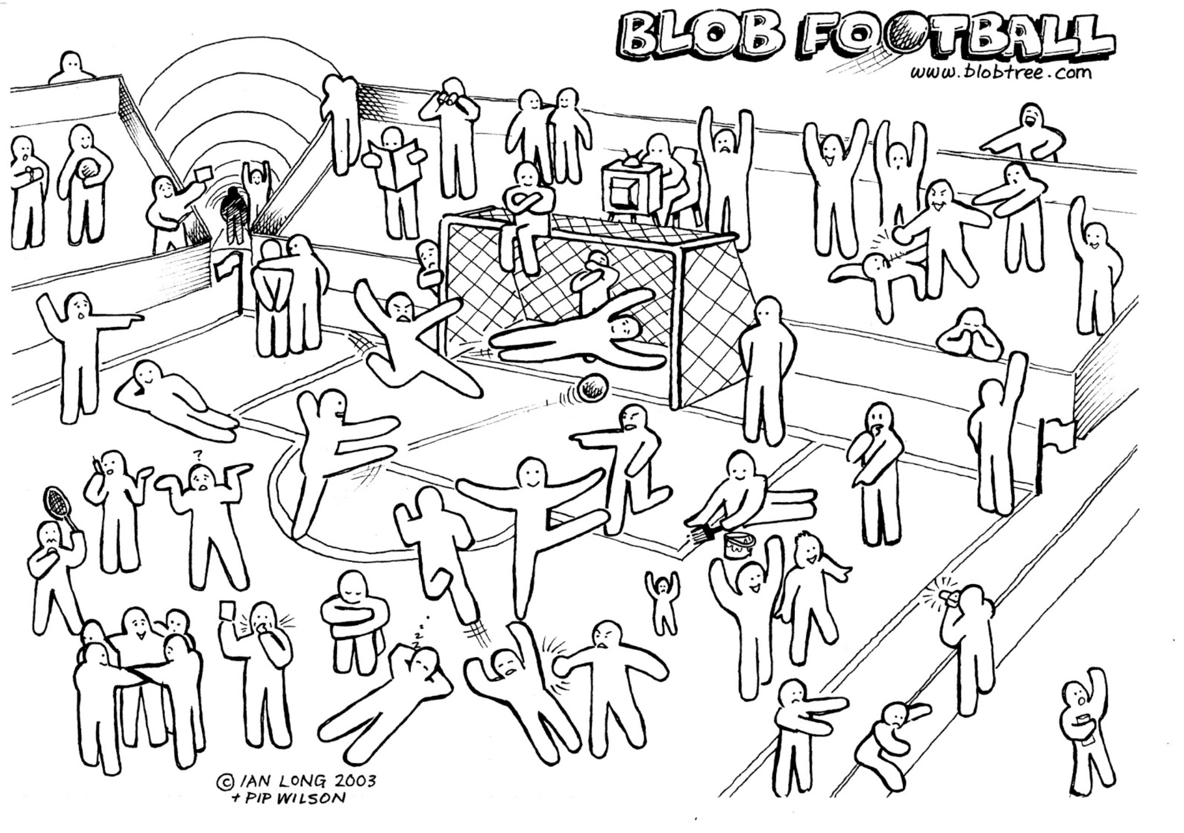

BLOB football
CO-OPERATING | NOT CO-OPERATING

TASK B: Create a poster or a brochure to display in the classroom that explains what CO_OPERATION is, and what CO_OPERATION is not. Use WORDS, PHRASES & IMAGES to make your statement clear and easy to read at school from a distance.
You can make your poster about just one of the areas above, eg, in the classroom or in the playground or a combination of areas.

The purpose of your poster or brochure is to encourage others to be CO-OPERATIVE.

TASK C: You have been asked to make a short story book to teach PREP students about the value of CO-OPERATION. In the design, consider that it will be read aloud so should be fun and engaging so you get your message across.

TASK D: Create a set of co-operation strategies/ideas that could help your class run smoothly; for example Strategy 1: Give everyone a role in group work. Roles such as leader, time keeper, materials manager, encourager.

*MANGA HIGH CHALLENGES: Log into your Manga High account with your user name and password. Complete 1, 2 or all 3 challenges.

WEEK 7 SPELLING:
brochure | co- operating | character | bullying | encourage | behaviours
engaging | unengaged | disengaged | resilient | collaborate | empathy

